UTSCsignatureFINAL211107 **P│S│C│B│9│0**

**Letters**

*2019, Volume 1, Issue 1*

**Sol-Gel based Amine Functionalized Silica for CO2 adsorption**

Bhrugu Patel, Geetu Sharma, Oleksandr Voznyy *

*Department of Physical and Environmental Sciences, University of Toronto Scarborough,*

*1065 Military Trial, Scarborough, ON, M1C 1A4*

Received: August 2nd, 2019; E-mail: o.voznyy@utoronto.ca

**Abstract –** In this work, we present the synthesis of amine functionalized silica particles aimed at CO2 capture. The particles with sheet and wrinkled morphologies are achieved using two different silica sources by sol-gel technique. The resulting particles were characterized using FT-IR which showed the formation of Si-O-Si linkages and the presence of amine groups. Scanning electron microscopy (SEM) was done to see the morphology of the final products. The results indicate that type and position of amines in the silica source could change the morphology of the final product. The wrinkled morphologies could easily trap small CO2 molecules in their grooves, thus demonstrating more viability in CO2 uptake.

**Introduction:**

Currently, CO2 emission into the atmosphere is a major contributor to global warming which is caused by the consumption of ever-increasing amounts of fossil fuels including coal, petroleum and natural gas. Thus, several technologies such as physical adsorption, chemical adsorption, membrane separation, and cryogenic separation have been developed to deal with CO2 emissions.  Activated carbon, mesoporous silica, zeolites, and metal-organic frameworks (MOFs), are some of the common adsorbents for CO2 capture which usually have a large surface area (Zhao et al., 1998; Narayan et al., 2018; Hu et al., 2019). The solid adsorbents are known to be more energy efficient in comparison to liquid amine sorption. However, low adsorption capacities and selectivity are some of the existing problems associated with them. Therefore, introduction of amines into the porous adsorbent structure has attracted a great interest. Amine adsorption involves the chemical reaction between carbon dioxide and the active amines to produce ammonium carbamate as shown in eqation (I) under anhydrous conditions. However, under hydrous conditions it results in the formation of ammonium carbonate as shown in equation (II) ():

CO2+2R−NH2 → R−NH3+ +R−NHCO­2− (I)

CO2+2R−NH2+H2O→ R−NH3+HCO3- (II)

The amine-functionalized adsorbents not only combine the advantageous properties of high CO2 affinity of amines and porous materials (large pore volume and large surface area) but also has high thermal stabilities (Bayal et al., 2016).

In the present study, we have synthesized silica particles using sol-gel method. Sol-gel method is used because it is one of the most flexible and versatile approach for obtaining diverse range of materials. This method not only allows to achieve differing chemistries but also has the wide range of producing micro/-nano silica structures of various morphologies. Since its inception, the sol-gel method involves the use of silica source i.e. tetraethyl orthosilicate (TEOS) (Serra et al., 2016). However, we have used 3-Trimethoxysilylpropyl diethylenetriamine and N-(2-Aminoethyl)-3-aminopropyltrimethoxysilane as silica sources which contains amine groups at different positions and eliminates the impregnation step to introduce the amine species later in the synthesis (Kishor and Ghoshal, 2017). This also reduces the chances of inhomogeneity of amine species inside the silica structure.

**Synthesis:**

The synthesis of silica particles was carried out by modification of previously reported approach (Bayal et al., 2016). 3-Trimethoxysilylpropyl diethylenetriamine (TMS-EDTA) and N-(2-Aminoethyl)-3-aminopropyltrimethoxysilane (AEAPTMS) (Scheme 1) were used as silica sources (instead of TEOS) and the reaction was done by usual sol-gel method without the use of microwave irradiation. Urea was used as a hydrolyzing/condensation reagent and cetyltrimethylammonium bromide (CTAB) was used as a template in a water: cyclohexane: 1-pentanol solvent mixture. Typically, cetyltrimethylammonium bromide (CTAB) (0.75 g, 8.23 mmol) and urea (0.9 g, 60 mmol) were first dissolved in deionized water (75 mL) by vigorously stirring for 10 minutes in a beaker. To the above mixture, a solution of TMS-EDTA (18.55 mL, 70 mmol) in cyclohexane (75 mL) was added dropwise for a period of 20 minutes under stirring by using a burette and then stirred for another 15 minutes. Subsequently, 1-Pentanol (4.5 mL) was added dropwise to above mixture in 5 minutes under stirring, and the obtained white slurry was further stirred for several minutes (2 hours). Afterwards, the slurry was heated to 80 oC and allowed to evaporate under stirring. On evaporation, the white slurry changes from transparent yellow solution to gel which was scratched using spatula and finally dried under vacuum overnight. Similar procedure was carried out using AEAPTMS as a silica source. This trial however, used 15.76 mL of AEAPTMS (71 mmol). The product synthesized using TMS-EDTA is given the name, S-1, and the product synthesized from AEAPTMS will be labeled S-2.

We also tried to do the same reactions using hydrothermal approach but could not succeed which might be due to the presence of excess of solvent in the reaction mixture which does not evaporate in closed vessel and prevented the formation of gel.

|  |  |  |  |  |
| --- | --- | --- | --- | --- |
| **Step 1: Hydrolysis** |  |  |  |  |
|  | + |  | ⇌ |  |
|  | | | | |
| **Step 2: Condensation** |  |  |  |  |
|  | + |  | ⇌ |  |

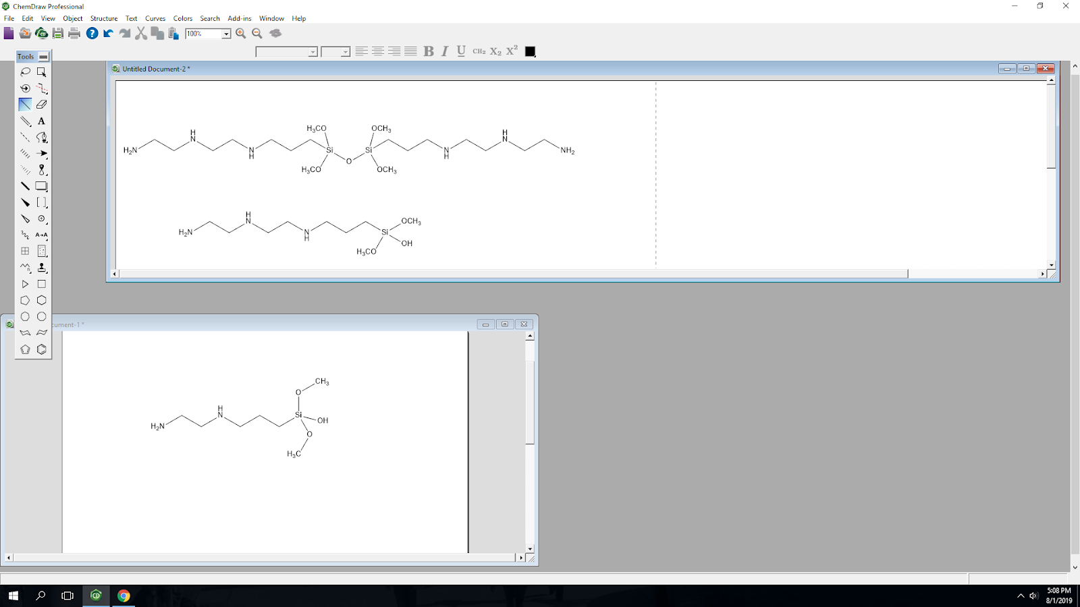

**Scheme 1:** Reaction scheme of the sol-gel process.

**Characterization:**

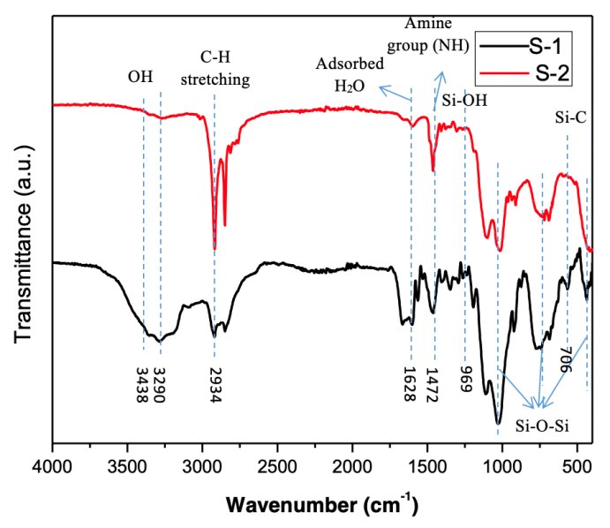 The amine functionalized silica composites were characterized using different analytical techniques such as infrared spectroscopy (FTIR) and scanning electron microscopy (SEM). IR spectra were recorded using an Alpha I FTIR Spectrometer (Fig. 1). The morphology of the silica composites was analyzed using Hitachi S530 SEM.

**Fig 1.** FT-IR spectra of S-1 and S-2 samples.

**Results and Discussion:**

Typically, sol-gel process is based on two steps involving hydrolysis and condensation reactions from metal alkoxide as the silica or parent source. A schematic representation of the process is shown in Scheme-1. The hydrolysis product called sol is more reactive than unhydrolyzed precursor. Therefore, condensation reaction takes place rapidly after hydrolysis. Condensation step leads to the formation of Si-O-Si bonds on release of alcohol molecule and leads to the formation of gel. The gel upon ageing forms three-dimensional network and consequently the viscosity of sol increases. In our study, we have done slow heating after the gel formation to get rid of all the extra solvents.

The FTIR spectra for S-1 and S-2 is shown in Fig. 3 The spectra showed the following peaks: 700-720 cm­-1, 950-970 cm­-1, 1450-1500 cm­-1, 2900-3000 cm­-1, and 3400-3500 cm­-1. Both samples show bands near 3438 cm-1 and 1630 cm-1 attributed to O-H stretching and bending, respectively due to adsorbed water molecules. The S-2 has a steeper peak around 2934 cm-1 due to C-H stretching. Both samples contain peaks around 1472 cm-1 indicating the presence of Si-OH bonds, formed during the hydrolysis of the initial silica molecule (Colleoni et al., 2016). The bands around 450 cm-1, 740 cm-1, and 1050 cm-1 all indicate the presence of Si-O-Si linkages. So, the FT-IR spectra confirms the formation of gel in both the samples.

SEM images of both S-1 and S-2 at different magnifications are shown in Fig. 2 and 3. The SEM images obtained from S-1 (Fig. 1) show the formation of sheet-like morphology. However, S-2 shows wrinkled morphology which is clearly visible in all the images (Fig. 2). The images were taken at different areas for both the samples which indicate overall homogeneity in the samples.

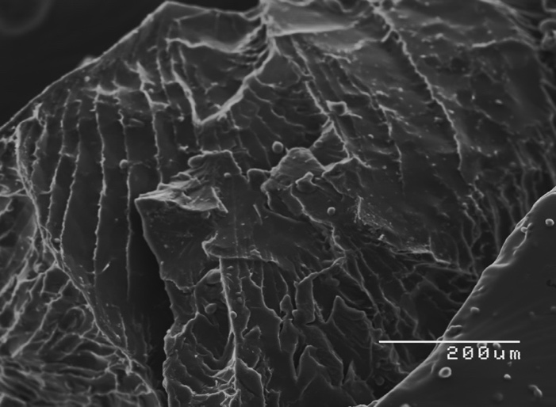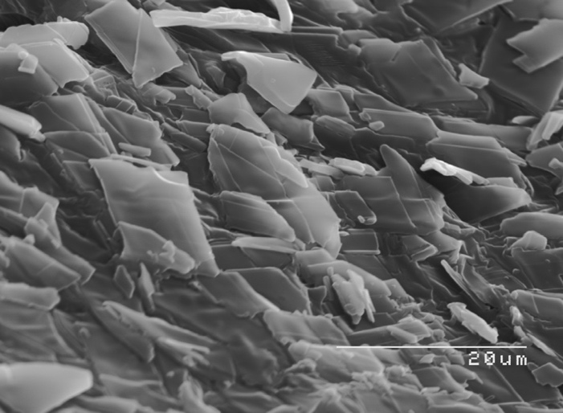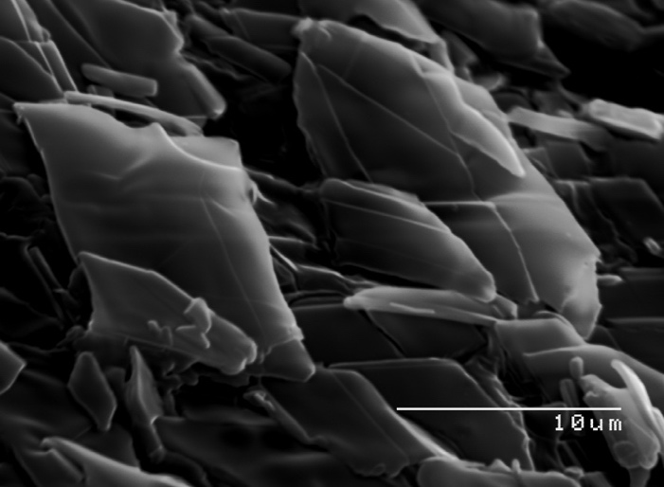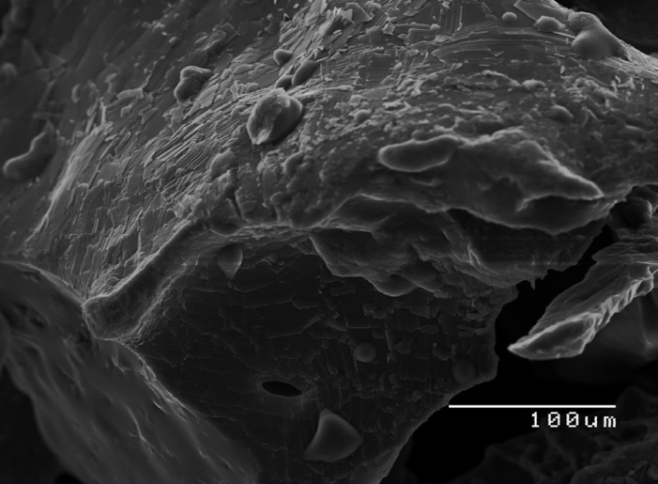

**Fig. 2** SEM images of S-1 at different magnifications.

The formation of the silica flakes was due to a facile method which could be attributed to a high pentanol to water concentration which prevented the formation of micelles (Shan et al., 2005). The thickness of the silica flakes was directly correlated to the concentration of the silica source. Silica flakes have presented a couple advantageous qualities such as having a higher rate and larger quantity of adsorbing molecules such as CO2 (Shan et al., 2005). They exhibited superior performance in adsorbing biomolecules within their mesopores and could be expected to show advantages when applied as a support for catalysts (Mijowska et al., 2015).

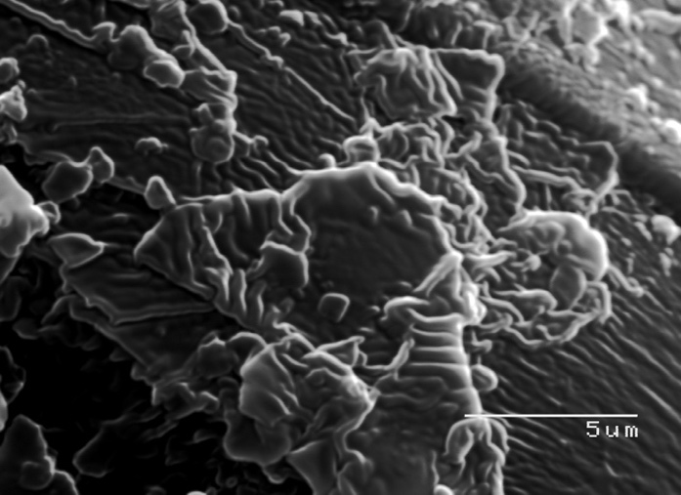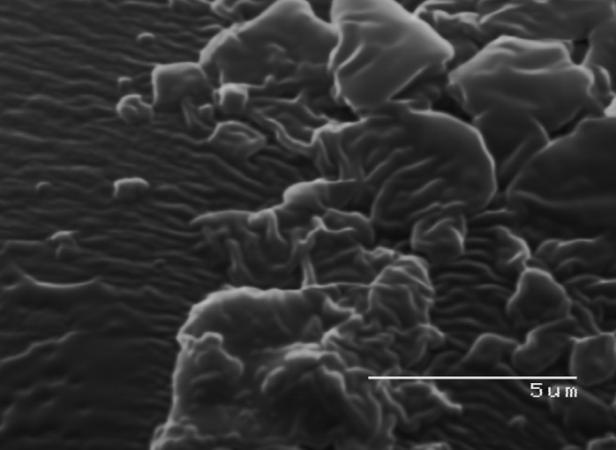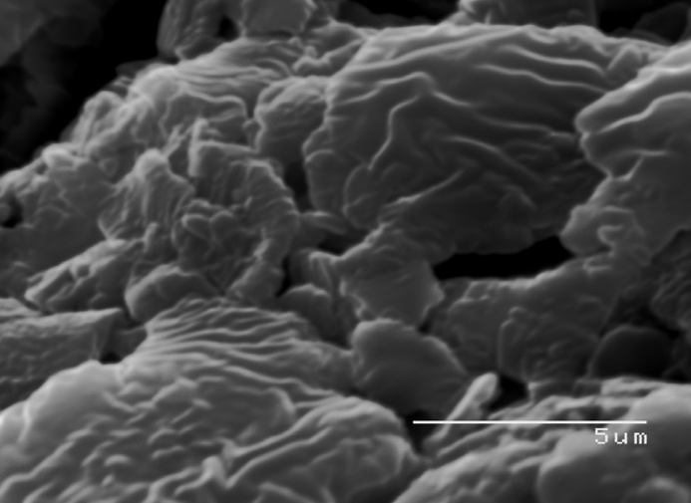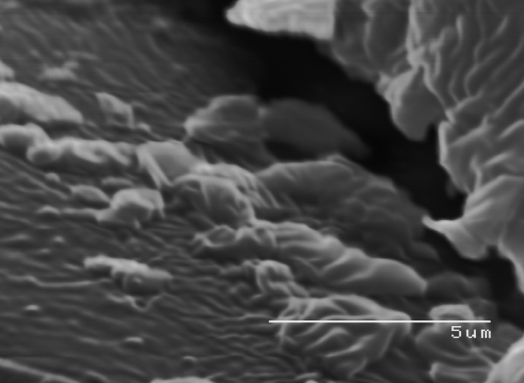

**Fig. 3** SEM images of S-2 at the same magnification

The formation of the wrinkled structure was generated by the formation of a shell through the cross-linking of silica molecules, followed by shrinking of the core through polymerization (Hano et al., 2017). Wrinkled silica nanoparticles have applications within drug delivery and catalysis, benefitting from the small size in the nanometer range and large surface-to-volume ratio which allows for their dispersion in various solvents (Moon and Lee, 2012).

The present samples will be further analyzed using high resolution TEM/SEM and also BET for the surface area measurements will be conducted to know the surface area and porosity in the samples. Finally, the samples will be used as CO2 adsorbents.

**Conclusion:**

In summary, we have presented a synthetic procedure for amine-functionalized silica nanoparticles using a sol-gel approach. The characterization of silica with flakes and wrinkled morphology was done using FT-IR and SEM. The synthetic route does not need any post synthetic treatment to introduce amine groups. 73.5% (14.56 grams) of product yield was obtained using TMS-EDTA and 76.4% (13.02 gram) was obtained using AEAPTMS as the silica sources. The SEM results show a change in morphology with change in position of amine groups in the silica source. The resulting materials are expected to show better CO2 adsorbent capacity and can be used in other applications such as catalysis and drug delivery.

**References:**

Bayal, N.; Singh, B.; Singh, R.; Polshettiwar, V. *Sci. Rep.* **2016**, 6, 24888; Doi: 10.1038/srep24888.

Colleoni, C.; Esposito, S.; Grasso, R.; Gulino, M.; Musumeci, F.; Romeli, D.; Rosace, G.; Salesi, G.; Scordino, A. *Phys. Chem. Chem. Phys*. **2016**, 18 (2), 772-780. Doi: 10.1039/C5CP03420E

Hano, N.; Takafuji, M.; Ihara, H. *Chem. Commun.*, **2017**, 53, 9147. Doi: 10.1039/c7cc05132h

Hu, Z.; Wang, Y.; Shah, B. B.; Zhao, D. *Adv. Sustainable Syst.* **2018**, 3(1) 1-21. Doi: 10.1002/adsu.201800080

Kishor, R. and Ghoshal, A.K. *Ind. Eng. Chem. Res.* **2017**, 56, 6078-6087. Doi:10.1021/acs.iecr.7b00890

Moon, D. and Lee, J. *Langmuir*, **2012**, 28, 12341-12347. dx.doi.org/10.1021/la302145j

Narayan, R.; Nayak, U.Y.; Raichur, A.M.; Garg, S. *Pharmaceutics* **2018**, 10(3). Doi: 10.3390/pharmaceutics10030118.

Shan, W.; Wang, B.; Zhang, Y.; Tang, Y. *Chem. Comm.* **2005**, 1877-1879. Doi: 10.1039/b418006b

Serra, A.; Ramis, X.; Fernandez-Francos, X. *Coatings* **2016**, 6(1), 8. https://doi.org/10.3390/coatings6010008

Zhao, X.S.; Ma, Q.; Lu, G.Q. *Energy Fuels* **1998**, 12(6) 1051-1054. https://doi.org/10.1021/ef980113s